________________

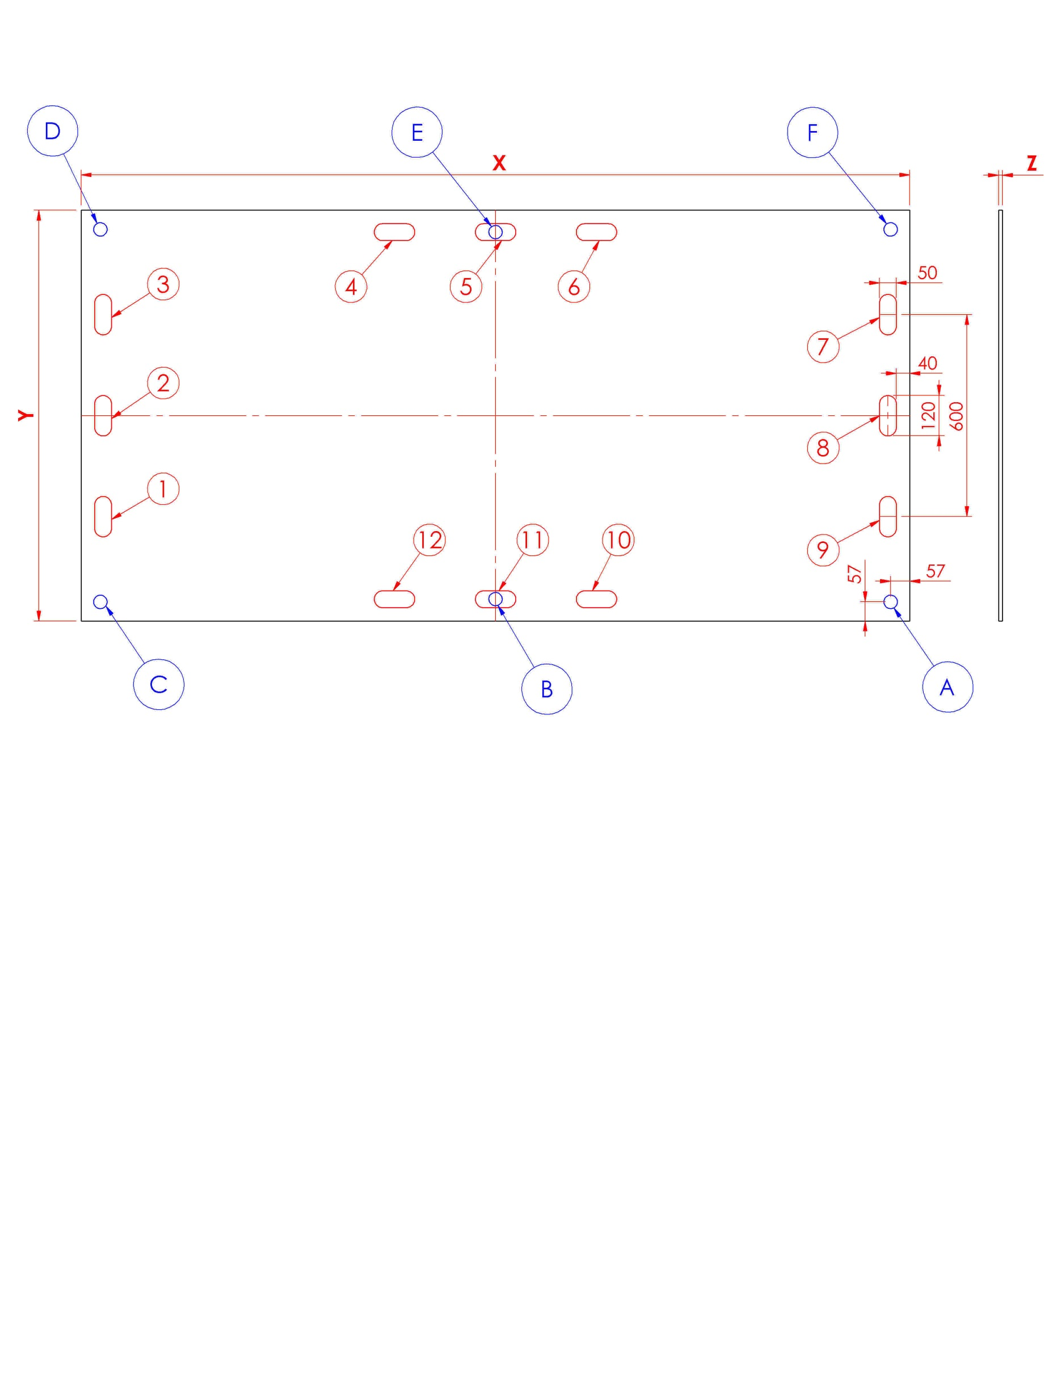
Comment/Bemerkungen:
Amount/Anzahl :

Amount/Anzahl pr. palle/pro Palette
___________ stk.

Write your desired DAN- Board measurements underneath.
X | Mm
Y | Mm
Z | Mm
Fastening hole positions,
select via (X) underneath.
A
B
C
D
E
F
Select your desired size of fastening holes in the board.
Ø25
Ø30
Ø40
Custom

Logo :______________
DATE: ________ CUSTOMER SIGNATURE: _____________________
Delivery of plates :
Date :
Receiver :
Plates returned :
Date : ______________

Handles measure: 50mm x 120mm. Select position (X)
1
2
3
4
5
6
7
8
9
10
11
12

